Exercises — Vapor Compression Refrigeration Cycle
Table of Contents

1.3 Vapor Compression Refrigeration Cycle

1.3.1 Thermodynamic Foundation — Latent Heat and Phase Change
The vapor compression refrigeration cycle exploits a fundamental property of matter: when a substance changes phase (liquid → vapor or vapor → liquid), it absorbs or releases a large quantity of heat without changing temperature. This heat is called latent heat.
Sensible heat changes the temperature of a substance without changing its phase. Latent heat changes the phase of a substance without changing its temperature.
Source: ASHRAE Fundamentals Handbook, Chapter 2
For a refrigerant at its boiling point: - Evaporation (liquid → vapor): absorbs latent heat from the surroundings → surroundings become cooler - Condensation (vapor → liquid): releases latent heat to the surroundings → surroundings become warmer
This is the mechanism by which a refrigerator or air conditioner moves heat from a cold space (indoors) to a warm space (outdoors).
Figure 1.8 shows the latent heat concept: a refrigerant boiling at constant temperature absorbs heat from the warm room air passing over the evaporator coil, cooling the air without any temperature change in the refrigerant during boiling.
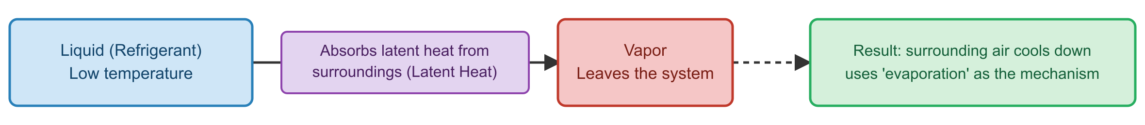
Figure 1.8 — Latent Heat — Phase Change at Constant Temperature
Figure 1.8 — Latent Heat — Phase Change at Constant Temperature
Source: ASHRAE Fundamentals Handbook, Chapter 2
Key insight: By selecting a refrigerant whose boiling point is well below room temperature at a given pressure, the engineer ensures that the refrigerant boils (and therefore absorbs heat) when exposed to room-temperature air — even though that air seems “cool” to a human.

1.3.2 The Four-Component Refrigeration Loop
The standard vapor compression refrigeration cycle circulates refrigerant through four components connected in a closed loop. Each component performs one thermodynamic function.
Figure 1.9 shows the complete refrigeration loop with refrigerant flow direction and the state of the refrigerant (liquid or vapor) at each point.
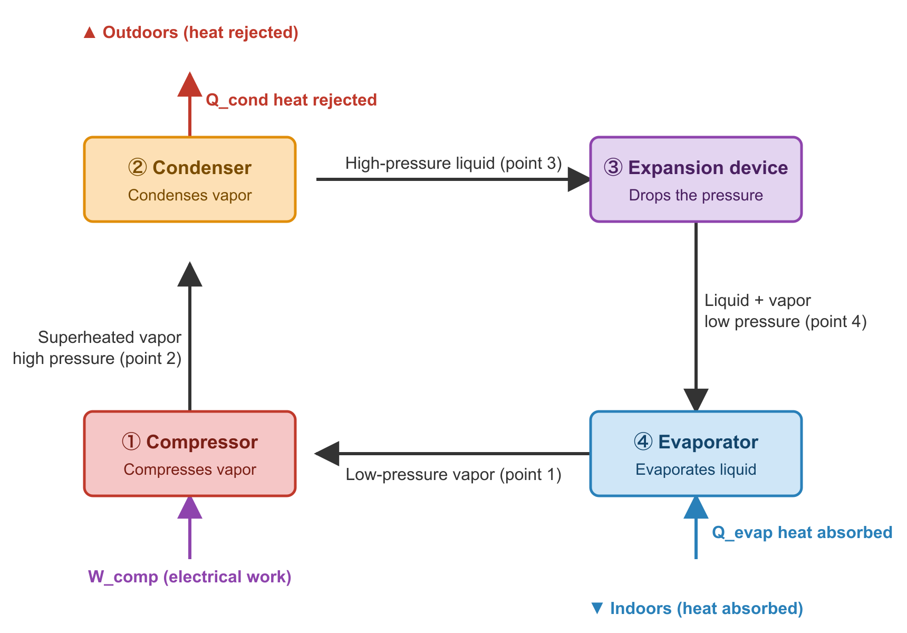
Figure 1.9 — Vapor Compression Refrigeration Cycle — Four-Component Loop
Figure 1.9 — Vapor Compression Refrigeration Cycle — Four-Component Loop
Source: ASHRAE Fundamentals Handbook, Chapter 2

Component 1 — Compressor
Function: Raises the pressure (and temperature) of the refrigerant vapor.
The compressor draws in low-pressure, low-temperature vapor from the evaporator and delivers high-pressure, high-temperature vapor to the condenser. Raising the pressure raises the saturation temperature — the refrigerant can now condense (release heat) at a temperature high enough to reject heat to the warm outdoor air.
- Input: electrical power (W or kW)
- Output: pressurized vapor + heat of compression
- Common types: reciprocating, scroll, screw, centrifugal (covered in Topic 1.4)

Component 2 — Condenser
Function: Removes heat from the refrigerant, converting high-pressure vapor to high-pressure liquid.
Hot refrigerant vapor from the compressor flows through the condenser coil. Outdoor air (or cooling water) flows over the coil and absorbs the heat, cooling the refrigerant until it condenses to liquid. The heat rejected here equals the heat absorbed from the conditioned space plus the heat added by the compressor.
$$Q_{cond}=Q_{evap}+W_{comp}$$
where: - $Q_{cond}$ = heat rejected at condenser (Btu/h or kW) - $Q_{evap}$ = heat absorbed at evaporator = cooling capacity (Btu/h or kW) - $W_{comp}$ = compressor power input (Btu/h or kW)

Component 3 — Expansion Device
Function: Drops the pressure of the liquid refrigerant, lowering its temperature below the space being cooled.
High-pressure liquid refrigerant passes through a small orifice or valve. The sudden pressure drop causes partial flash evaporation — a small fraction of the liquid vaporizes, cooling the remaining liquid to the low evaporating temperature. The refrigerant enters the evaporator as a cold, low-pressure liquid-vapor mixture.
- Common types: thermostatic expansion valve (TXV), electronic expansion valve (EEV), capillary tube

Component 4 — Evaporator
Function: Absorbs heat from the conditioned space, evaporating the refrigerant.
Cold refrigerant (liquid-vapor mix) flows through the evaporator coil inside the air handling unit. Warm room air passes over the coil; the refrigerant absorbs the latent heat needed to complete its evaporation. The air is cooled (and dehumidified — moisture condenses on the cold coil surface). The refrigerant leaves as low-pressure vapor, ready to return to the compressor.
- The cooling capacity $Q_{evap}$ is the useful output of the entire system
- Dehumidification occurs because the coil surface temperature is below the dew point of the room air

1.3.3 The Four Thermodynamic Processes
The refrigeration cycle consists of four distinct thermodynamic processes. Figure 1.10 shows these processes on a state diagram.
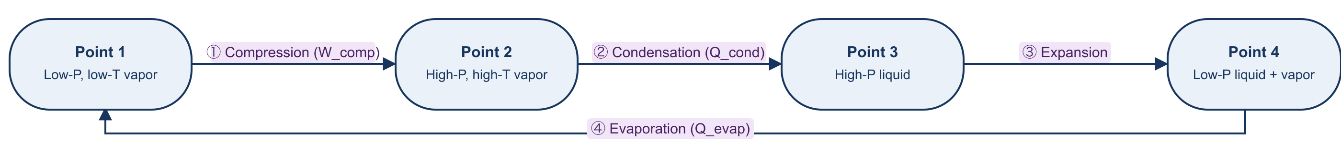
Figure 1.10 — Four Processes of the Vapor Compression Cycle
Figure 1.10 — Four Processes of the Vapor Compression Cycle
Source: ASHRAE Fundamentals Handbook, Chapter 2
Process 1→2 (Compression): The compressor raises refrigerant pressure. In an ideal cycle this is isentropic (adiabatic reversible); in practice, compressor inefficiency adds heat, making the discharge vapor superheated.
Process 2→3 (Condensation): Heat is removed from the refrigerant at constant pressure until it becomes saturated liquid. The temperature at which this occurs is the condensing temperature $T_{cond}$, which is above the outdoor ambient temperature so that heat flows outward.
Process 3→4 (Expansion): The expansion device is a throttle — no work is done and no heat is exchanged. Pressure drops, refrigerant temperature drops to the evaporating temperature $T_{evap}$, well below the room temperature.
Process 4→1 (Evaporation): Heat flows from the warm room air into the cold refrigerant. The refrigerant evaporates at constant pressure and constant temperature $T_{evap}$. This is the useful refrigerating effect.

1.3.4 The Pressure-Enthalpy (P-h) Diagram
The P-h diagram (also called the Mollier diagram for refrigerants) is the primary tool for analyzing and designing refrigeration cycles. The x-axis is specific enthalpy $h$ (Btu/lb or kJ/kg); the y-axis is absolute pressure $P$ (psia or kPa).
Figure 1.11 shows the P-h diagram with the vapor dome and the four cycle processes plotted as line segments.
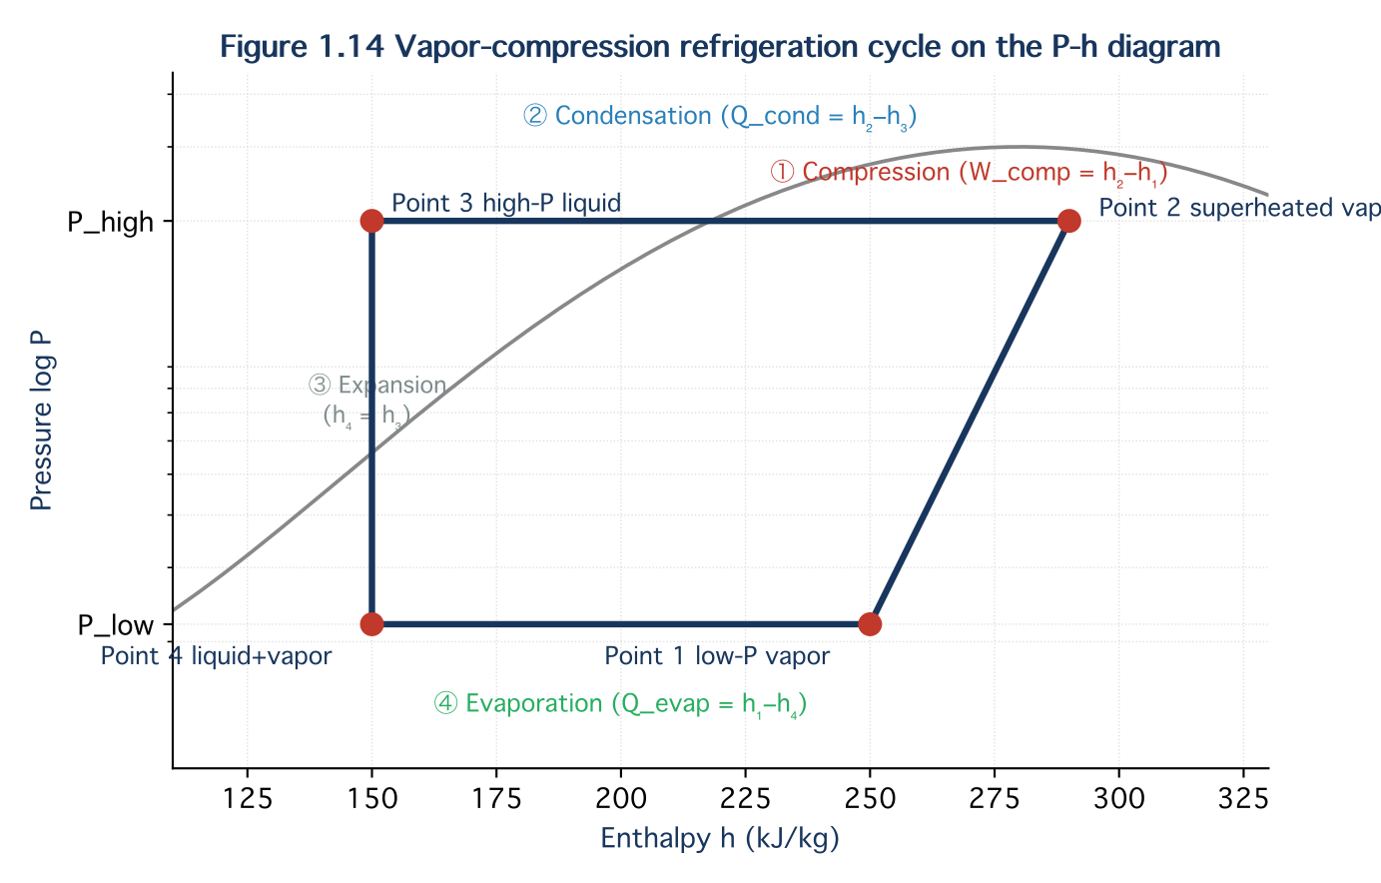
Figure 1.11 — Pressure-Enthalpy (P-h) Diagram — Vapor Compression Cycle
Figure 1.11 — Pressure-Enthalpy (P-h) Diagram — Vapor Compression Cycle
Source: ASHRAE Fundamentals Handbook, Chapter 2
Reading the P-h diagram:
Segment | Process | Direction on P-h
1→2 | Compression | Vertical up (pressure rises, enthalpy rises)
2→3 | Condensation | Horizontal left (pressure constant, enthalpy drops)
3→4 | Expansion | Vertical down (pressure drops, enthalpy ≈ constant)
4→1 | Evaporation | Horizontal right (pressure constant, enthalpy rises)
Key values read from the diagram:
$$\text{Refrigerating effect}=h_{1}−h_{4} \text{(Btu/lb or kJ/kg)}$$
$$\text{Compressor work}=h_{2}−h_{1} \text{(Btu/lb or kJ/kg)}$$
$$\text{Heat rejected (condenser)}=h_{2}−h_{3} \text{(Btu/lb or kJ/kg)}$$
Mass flow rate required for a given cooling capacity $Q_{evap}$:
$$\dot{m}=\frac{Q_{evap}}{h_{1}−h_{4}} \text{(lb/h or kg/s)}$$
IP example: If $h_{1}−h_{4}=70$ Btu/lb and required cooling = 120,000 Btu/h (10 TR):
$$\dot{m}=\frac{120,000}{70}=1,714\text{ lb/h}$$
SI equivalent: If $h_{1}−h_{4}=163$ kJ/kg and required cooling = 35.2 kW:
$$\dot{m}=\frac{35.2}{163}=0.216\text{ kg/s}$$

1.3.5 Coefficient of Performance (COP)
The Coefficient of Performance (COP) measures the efficiency of the refrigeration cycle — how much useful cooling is produced per unit of electrical energy consumed.
$$COP=\frac{Q_{evap}}{W_{comp}}=\frac{h_{1}−h_{4}}{h_{2}−h_{1}}$$
where all quantities are in consistent units (Btu/h or kW — the ratio is dimensionless).
Figure 1.12 shows typical COP ranges for different AC system types and operating conditions.
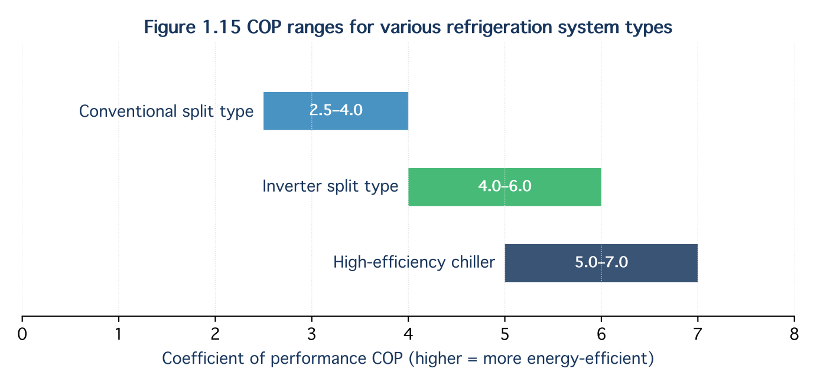
Figure 1.12 — Typical COP Ranges — Vapor Compression Systems
Figure 1.12 — Typical COP Ranges — Vapor Compression Systems
Source: ASHRAE Standard 90.1; ASHRAE Fundamentals Handbook
Relationship between COP and EER:
$$EER=COP×3.412 \text{(EER in Btu/h per W)}$$
Carnot COP (theoretical maximum):
$$COP_{Carnot}=\frac{T_{evap}}{T_{cond}−T_{evap}} \text{(temperatures in absolute scale: °R or K)}$$
IP example: $T_{evap}=45°F=505°R$, $T_{cond}=115°F=575°R$:
$$COP_{Carnot}=\frac{505}{575−505}=\frac{505}{70}=7.2$$
Real cycles achieve 50–70% of Carnot COP due to compressor inefficiency, pressure drops, and heat transfer temperature differences.

1.3.6 Practical Considerations — Subcooling and Superheating
Real refrigeration cycles include two modifications to improve reliability and efficiency:
Subcooling — cooling the liquid refrigerant below its saturation temperature before the expansion device: - Increases refrigerating effect: $Δ(h_{1}−h_{4})$ increases - Prevents flash evaporation in the liquid line (vapor bubbles would disrupt TXV operation) - Typical subcooling: 5–15°F (3–8°C)
Superheating — heating the vapor above its saturation temperature before the compressor: - Ensures only dry vapor enters the compressor (liquid refrigerant would damage compressor valves) - Typical superheat at compressor suction: 10–20°F (6–11°C)
Source: ASHRAE Fundamentals Handbook, Chapter 2

Summary — Topic 1.3
- Latent heat is the thermodynamic basis of refrigeration: refrigerant absorbs heat by evaporating at low pressure, rejects heat by condensing at high pressure
- Four components: Compressor (pressure up) → Condenser (heat out) → Expansion device (pressure down) → Evaporator (heat in)
- Four processes on the P-h diagram: compression (1→2), condensation (2→3), expansion (3→4), evaporation (4→1)
- Refrigerating effect = $h_{1}−h_{4}$; Compressor work = $h_{2}−h_{1}$; read directly from P-h diagram
- COP = $Q_{evap}/W_{comp}$; typical range 2.5–7.5 depending on system type and conditions
- Subcooling improves efficiency; Superheating protects the compressor

Reference: ASHRAE Fundamentals Handbook, Chapter 2; Praphan, Air Conditioning Engineering Status: draft — English version, written fresh from source

Worked Examples — Topic 1.3: Vapor Compression Refrigeration Cycle

Example 1.3.1 — Reading the P-h Diagram: Cycle Performance of R-410A
Problem: A split-type air conditioner uses refrigerant R-410A. From the P-h diagram, the following enthalpies are read at the four state points:
State | Location | Enthalpy
1 | Compressor inlet (suction) | h₁ = 128.5 Btu/lb (299.0 kJ/kg)
2 | Compressor outlet (discharge) | h₂ = 148.2 Btu/lb (344.9 kJ/kg)
3 | Condenser outlet (liquid) | h₃ = 58.3 Btu/lb (135.6 kJ/kg)
4 | Evaporator inlet (after expansion) | h₄ = 58.3 Btu/lb (135.6 kJ/kg)
The system has a rated cooling capacity of 36,000 Btu/h (10.6 kW).
Calculate: (a) Refrigerating effect per unit mass (Btu/lb and kJ/kg) (b) Compressor work per unit mass (Btu/lb and kJ/kg) (c) Heat rejected at the condenser per unit mass (Btu/lb and kJ/kg) (d) Mass flow rate of refrigerant required (lb/h and kg/s) (e) COP and EER of this cycle
Solution:
(a) Refrigerating effect:
$$q_{evap}=h_{1}−h_{4}=128.5−58.3=70.2\text{ Btu/lb} (299.0−135.6=163.4\text{ kJ/kg})$$
(b) Compressor work:
$$w_{comp}=h_{2}−h_{1}=148.2−128.5=19.7\text{ Btu/lb} (344.9−299.0=45.9\text{ kJ/kg})$$
(c) Heat rejected at condenser:
$$q_{cond}=h_{2}−h_{3}=148.2−58.3=89.9\text{ Btu/lb} (344.9−135.6=209.3\text{ kJ/kg})$$
Verification: $q_{cond}=q_{evap}+w_{comp}=70.2+19.7=89.9$ Btu/lb ✓
(d) Mass flow rate:
$$\dot{m}=\frac{Q_{evap}}{q_{evap}}=\frac{36,000\text{ Btu/h}}{70.2\text{ Btu/lb}}=513\text{ lb/h}$$
SI: $\dot{m}=\frac{10.6\text{ kW}}{163.4\text{ kJ/kg}}=0.0649\text{ kg/s}$
(e) COP and EER:
$$COP=\frac{q_{evap}}{w_{comp}}=\frac{70.2}{19.7}=3.56$$
$$EER=COP×3.412=3.56×3.412=12.1\text{ Btu/h per W}$$
Observation: A COP of 3.56 means the system delivers 3.56 units of cooling for every unit of electrical energy consumed. This is a typical value for a standard residential split-type unit operating under design conditions.
Source: ASHRAE Fundamentals Handbook, Chapter 2

Example 1.3.2 — Carnot COP vs. Real COP: Effect of Operating Temperatures
Problem: An air conditioning system maintains a room at 75°F (24°C). The condensing temperature (outdoor heat rejection) is 115°F (46°C) and the evaporating temperature is 45°F (7°C).
(a) Calculate the Carnot (ideal maximum) COP for these operating conditions. (b) If the actual system COP is 3.8, what is the cycle efficiency (ratio of actual to Carnot COP)? (c) The building owner wants to improve efficiency by installing a more effective condenser that reduces the condensing temperature to 100°F (38°C). Recalculate the Carnot COP and explain the engineering significance.
Solution:
(a) Carnot COP (original conditions):
Convert to absolute temperatures (Rankine = °F + 459.67):
$$T_{evap}=45+459.67=504.67\text{ °R}$$
$$T_{cond}=115+459.67=574.67\text{ °R}$$
$$COP_{Carnot}=\frac{T_{evap}}{T_{cond}−T_{evap}}=\frac{504.67}{574.67−504.67}=\frac{504.67}{70}=7.21$$
SI check: $T_{evap}=7+273.15=280.15$ K, $T_{cond}=46+273.15=319.15$ K
$$COP_{Carnot}=\frac{280.15}{319.15−280.15}=\frac{280.15}{39}=7.18≈7.2\text{ ✓}$$
(b) Cycle efficiency:
$$η_{cycle}=\frac{COP_{actual}}{COP_{Carnot}}=\frac{3.8}{7.21}=52.7\%$$
This is typical for real vapor compression systems (50–70% of Carnot), accounting for compressor irreversibilities, heat transfer temperature differences, and pressure drops.
(c) Improved condenser — condensing temperature 100°F (38°C):
$$T_{cond,new}=100+459.67=559.67\text{ °R}$$
$$COP_{Carnot,new}=\frac{504.67}{559.67−504.67}=\frac{504.67}{55}=9.18$$
Engineering significance: Reducing condensing temperature from 115°F to 100°F (only 15°F / 8°C improvement) raises the Carnot COP from 7.21 to 9.18 — an increase of 27%. If the real system maintains 52.7% cycle efficiency, the new actual COP would be approximately $9.18×0.527=4.84$ — a 27% improvement in efficiency from a modest reduction in condensing temperature.
Practical implication: Improving heat rejection (larger condenser, lower ambient temperature, cooling tower instead of air-cooled condenser) has a larger impact on system efficiency than almost any other single measure.
Source: ASHRAE Fundamentals Handbook, Chapter 2

Example 1.3.3 — Heat Balance: What Happens at the Condenser?
Problem: A 5-ton (60,000 Btu/h / 17.6 kW) air conditioner has a measured COP of 3.2. The condensing unit is located on the roof.
(a) How much electrical power does the compressor consume? (kW and Btu/h) (b) How much total heat is rejected to the outdoor air at the condenser? (Btu/h and kW) (c) If 10 identical units serve a 10-story office building, what is the total heat load imposed on the roof environment? Express in kW and in equivalent tons of refrigeration.
Solution:
(a) Compressor power:
$$W_{comp}=\frac{Q_{evap}}{COP}=\frac{17.6\text{ kW}}{3.2}=5.5\text{ kW}$$
IP: $W_{comp}=\frac{60,000\text{ Btu/h}}{3.2}=18,750\text{ Btu/h}$
(b) Heat rejected at condenser:
$$Q_{cond}=Q_{evap}+W_{comp}=17.6+5.5=23.1\text{ kW}$$
IP: $Q_{cond}=60,000+18,750=78,750\text{ Btu/h}$
Note: The condenser always rejects more heat than the system removes from the building — the extra heat is the compressor work converted to heat.
(c) Total rooftop heat rejection — 10 units:
$$Q_{roof,total}=10×23.1=231\text{ kW}$$
IP: $231\text{ kW}÷3.517=65.7\text{ TR}$
Practical implication: The rooftop mechanical engineer must ensure adequate ventilation and spacing between condensing units. If units are clustered too closely, recirculation of hot discharge air raises the ambient temperature around each unit, increasing condensing temperature, reducing COP, and in extreme cases causing high-pressure trips. ASHRAE recommends minimum clearances of 24 inches (600 mm) on all sides of air-cooled condensers.
Source: ASHRAE Fundamentals Handbook, Chapter 2; ASHRAE Standard 90.1

Reference: ASHRAE Fundamentals Handbook, Chapter 2; Praphan, Air Conditioning Engineering Status: draft — English version, written fresh from source

Exercises — Topic 1.3: Vapor Compression Refrigeration Cycle
Difficulty: ★ Easy · ★★ Moderate · ★★★ Challenging

Exercise 1 ★
Match each component of the vapor compression cycle to its function and the state change it causes:
Component | Function | Refrigerant state change
Compressor | (a) _____ | (i) _____
Condenser | (b) _____ | (ii) _____
Expansion device | (c) _____ | (iii) _____
Evaporator | (d) _____ | (iv) _____
Functions: Absorbs heat from conditioned space / Raises refrigerant pressure / Drops refrigerant pressure / Rejects heat to outdoors
State changes: Vapor → High-pressure vapor / Liquid → Liquid-vapor mix / Liquid-vapor mix → Vapor / High-pressure vapor → Liquid
Answer
Component | Function | State change
Compressor | Raises refrigerant pressure | Low-pressure vapor → High-pressure vapor
Condenser | Rejects heat to outdoors | High-pressure vapor → High-pressure liquid
Expansion device | Drops refrigerant pressure | High-pressure liquid → Low-pressure liquid-vapor mix
Evaporator | Absorbs heat from conditioned space | Low-pressure liquid-vapor mix → Low-pressure vapor

Exercise 2 ★
A refrigeration system has the following enthalpy values read from a P-h diagram:
- $h_{1}$ (compressor inlet) = 185 kJ/kg
- $h_{2}$ (compressor outlet) = 220 kJ/kg
- $h_{3}$ (condenser outlet) = 80 kJ/kg
- $h_{4}$ (evaporator inlet) = 80 kJ/kg
Calculate: (a) Refrigerating effect per kg (kJ/kg and Btu/lb) (b) Compressor work per kg (kJ/kg) (c) COP of the cycle (d) Verify using the heat balance: $q_{cond}=q_{evap}+w_{comp}$
Conversion: 1 Btu/lb = 2.326 kJ/kg
Answer
(a) Refrigerating effect:
$$q_{evap}=h_{1}−h_{4}=185−80=105\text{ kJ/kg}$$
$$=105÷2.326=45.1\text{ Btu/lb}$$
(b) Compressor work:
$$w_{comp}=h_{2}−h_{1}=220−185=35\text{ kJ/kg}$$
(c) COP:
$$COP=\frac{q_{evap}}{w_{comp}}=\frac{105}{35}=3.0$$
(d) Heat balance verification:
$$q_{cond}=h_{2}−h_{3}=220−80=140\text{ kJ/kg}$$
$$q_{evap}+w_{comp}=105+35=140\text{ kJ/kg}✓$$

Exercise 3 ★
Convert the following COP values to EER, and vice versa. State which system is more efficient in each pair.
(a) System A: COP = 3.5 → EER = ? (b) System B: EER = 14.0 → COP = ? (c) Which system (A or B) is more efficient?
Conversion: EER = COP × 3.412
Answer
(a) $EER_{A}=3.5×3.412=11.9\text{ Btu/h per W}$
(b) $COP_{B}=14.0÷3.412=4.10$
(c) System B is more efficient: COP 4.10 > COP 3.50 (EER 14.0 > EER 11.9).

Exercise 4 ★★
A 3-ton (36,000 Btu/h) air conditioner uses refrigerant R-410A. The P-h diagram gives:
$$h_{1}=125.0\text{ Btu/lb}, h_{2}=146.0\text{ Btu/lb}, h_{3}=h_{4}=55.0\text{ Btu/lb}$$
(a) Calculate the mass flow rate of refrigerant (lb/h and kg/h). (b) Calculate the compressor power consumption (Btu/h and kW). (c) Calculate the total heat rejected at the condenser (Btu/h and kW). (d) Calculate the COP and EER.
Conversion: 1 kW = 3,412 Btu/h; 1 lb = 0.4536 kg
Answer
(a) Mass flow rate:
$$q_{evap}=h_{1}−h_{4}=125.0−55.0=70.0\text{ Btu/lb}$$
$$\dot{m}=\frac{Q_{evap}}{q_{evap}}=\frac{36,000}{70.0}=514\text{ lb/h}$$
$$=514×0.4536=233\text{ kg/h}$$
(b) Compressor power:
$$w_{comp}=h_{2}−h_{1}=146.0−125.0=21.0\text{ Btu/lb}$$
$$W_{comp}=\dot{m}×w_{comp}=514×21.0=10,794\text{ Btu/h}$$
$$=10,794÷3,412=3.16\text{ kW}$$
(c) Heat rejected at condenser:
$$Q_{cond}=Q_{evap}+W_{comp}=36,000+10,794=46,794\text{ Btu/h}$$
$$=46,794÷3,412=13.7\text{ kW}$$
(d) COP and EER:
$$COP=\frac{36,000}{10,794}=3.34$$
$$EER=3.34×3.412=11.4\text{ Btu/h per W}$$

Exercise 5 ★★
An engineer is comparing two condensing temperatures for an R-410A system with a fixed evaporating temperature of 40°F (4.4°C):
- Option A: Air-cooled condenser, $T_{cond}$ = 120°F (48.9°C)
- Option B: Water-cooled condenser (cooling tower), $T_{cond}$ = 95°F (35°C)
(a) Calculate the Carnot COP for each option. (b) If both real systems achieve 55% of Carnot COP, what is the actual COP of each? (c) For a 100-ton (1,200,000 Btu/h / 352 kW) chiller, how much electrical power does each option consume? (kW) (d) If electricity costs 4 Baht/kWh and the chiller operates 3,000 hours/year, calculate the annual electricity cost savings from choosing Option B over Option A.
Answer
(a) Carnot COP:
Option A: $T_{evap}=40+459.67=499.67°R$; $T_{cond}=120+459.67=579.67°R$
$$COP_{Carnot,A}=\frac{499.67}{579.67−499.67}=\frac{499.67}{80}=6.25$$
Option B: $T_{cond}=95+459.67=554.67°R$
$$COP_{Carnot,B}=\frac{499.67}{554.67−499.67}=\frac{499.67}{55}=9.09$$
(b) Actual COP at 55% efficiency:
$$COP_{A}=6.25×0.55=3.44$$
$$COP_{B}=9.09×0.55=5.00$$
(c) Compressor power for 100-ton chiller:
$$W_{A}=\frac{352\text{ kW}}{3.44}=102.3\text{ kW}$$
$$W_{B}=\frac{352\text{ kW}}{5.00}=70.4\text{ kW}$$
(d) Annual savings:
$$ΔW=102.3−70.4=31.9\text{ kW}$$
$$\text{Annual savings}=31.9\text{ kW}×3,000\text{ h}×4\text{ Baht/kWh}=382,800\text{ Baht/year}$$
Conclusion: Switching from air-cooled to water-cooled condensing saves approximately 383,000 Baht/year for a 100-ton chiller — a compelling economic case for investing in a cooling tower despite the higher capital cost.

Exercise 6 ★★★
A supermarket refrigeration system uses a two-stage cascade cycle to achieve a very low evaporating temperature for frozen food storage (−20°F / −29°C). The high-stage cycle interfaces with the low-stage cycle through an intermediate heat exchanger (cascade condenser).
Given data for the low-stage cycle: - $h_{1}=90$ Btu/lb, $h_{2}=115$ Btu/lb, $h_{3}=h_{4}=20$ Btu/lb - Cooling load on frozen food display cases: 180,000 Btu/h (52.8 kW)
Given data for the high-stage cycle: - COP = 4.2 - The high-stage cycle must remove all the heat rejected by the low-stage condenser
(a) Calculate the COP of the low-stage cycle. (b) Calculate the compressor power of the low-stage cycle (kW). (c) Calculate the heat load the high-stage cycle must handle (Btu/h and kW). (d) Calculate the total electrical power consumed by both compressors (kW). (e) What is the overall system COP (total cooling output ÷ total electrical input)?
Answer
(a) Low-stage COP:
$$q_{evap,L}=h_{1}−h_{4}=90−20=70\text{ Btu/lb}$$
$$w_{comp,L}=h_{2}−h_{1}=115−90=25\text{ Btu/lb}$$
$$COP_{L}=\frac{70}{25}=2.80$$
(b) Low-stage compressor power:
$$W_{L}=\frac{Q_{evap,L}}{COP_{L}}=\frac{52.8\text{ kW}}{2.80}=18.9\text{ kW}$$
IP: $W_{L}=180,000÷2.80=64,286\text{ Btu/h}=18.8\text{ kW}$ ✓
(c) High-stage heat load (= low-stage condenser rejection):
$$Q_{cond,L}=Q_{evap,L}+W_{L}=52.8+18.9=71.7\text{ kW} (244,286\text{ Btu/h})$$
(d) High-stage compressor power:
$$W_{H}=\frac{Q_{cond,L}}{COP_{H}}=\frac{71.7}{4.2}=17.1\text{ kW}$$
Total compressor power:
$$W_{total}=W_{L}+W_{H}=18.9+17.1=36.0\text{ kW}$$
(e) Overall system COP:
$$COP_{overall}=\frac{Q_{evap,L}}{W_{total}}=\frac{52.8}{36.0}=1.47$$
Observation: The overall COP of 1.47 is much lower than a standard comfort cooling system (COP 3–5) because maintaining −20°F (−29°C) requires a very large temperature lift from evaporator to outdoor ambient — the Carnot limit itself is low at these conditions. The cascade arrangement improves efficiency compared to a single-stage system at these temperatures.
Source: ASHRAE Refrigeration Handbook

Reference: ASHRAE Fundamentals Handbook, Chapter 2; Praphan, Air Conditioning Engineering Status: draft — English version, written fresh from source

